International Day of Biological Diversity
CapeNature Infographic Quiz solution

- What is BIODIVERSITY?
- A type of coconut
- Plants, Animals, Bacteria and Fungi
- The variety of life on Earth
- A plant species

- What is one difference between animals and plants?
- Animals can move, plants cannot move
- Animals reproduce and have babies, plants lay eggs
- Plants eat other organisms, animals make their own food
- None of the above, they are the same

- Which of the following represent four of the kingdoms that all living things can be divided up into?
- Fungi, Bacteria, Protozoa and Animal Kingdoms
- Bacteria, Fungi, Animal and Plant Kingdoms
- Animal, Birds (Aves) and Plant and Insect Kingdoms
- Insects, Fungi, Bacteria and Plant Kingdoms

- Why is the Western Cape’s BIODIVERSITY special?
- A high number of endemic species (species found nowhere else on Earth)
- 3 – 4 % of the Worlds plant species are found here
- Has approximately 9 300 plant species
- All of the above

- BONUS QUESTION
Which Kingdom do you think provides 60% of the world’s medicine?
- Animals
- Bacteria
- Plants
- Fungi

Infographic KINGDOM CLASSIFICATION picture solution –
YELLOW ANIMAL
RED BACTERIA
PURPLE FUNGI
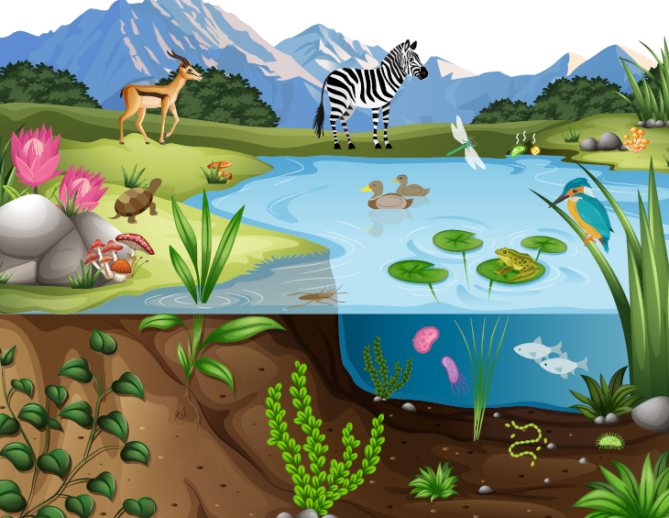
BLACK PLANT

